**RUNGTA COLLEGE OF ENGINEERING & TECHNOLOGY , BHILAI**

**DEPARTMENT OF COMPUTER SCIENCE AND ENGINEERING**

**Project Synopsis**

**Semester:** 6th B

**Project Title:** AI-Powered Virtual Salon Booking System

**Project Type:** Software Development

**Problem Statement:** Customers face difficulty selecting suitable hairstyles and visualizing outcomes before committing. Traditional salon booking methods are often inconvenient, time-consuming, and limited by operating hours. Salons lack efficient tools for personalized customer engagement, streamlined booking management, and data-driven insights into preferences and operational performance.

**Project Overview/ Abstract:** This project involves the development of an integrated webbased platform designed to enhance the salon experience for both customers and owners. The system leverages Artificial Intelligence (AI) for personalized hairstyle recommendations based on user features (analyzed via Computer Vision) and preferences, coupled with Augmented Reality (AR) for virtual try-ons. It incorporates a real-time, online appointment booking system, an AI-powered chatbot for instant customer support (FAQs, booking assistance), and a comprehensive dashboard for salon staff to manage services, schedules, appointments, and view analytics derived from customer feedback and booking trends. The goal is to improve customer satisfaction through personalization and convenience while streamlining salon operations.

**Objective:**

* To develop an AI module for personalized hairstyle recommendations based on facial analysis and user preferences.
* To implement an AR feature allowing users to virtually try on recommended hairstyles.
* To create a seamless, real-time online booking system with automated notifications.
* To build an AI chatbot to handle customer inquiries and assist with booking.
* To provide a dashboard for salons to manage services, staff, schedules, and appointments efficiently.
* To analyze customer feedback using AI (sentiment analysis) and provide actionable insights to salons.
* To enhance overall customer satisfaction and improve salon operational efficiency.

**Methodology:** The project will adopt an Agile software development methodology.

Key phases include:

1. **Requirement Gathering & Analysis:** Defining detailed functional and non-functional requirements.
2. **System Design:** Designing the system architecture, database schema (ERD), data flows (DFD), UI/UX mockups, and use cases.
3. **Implementation:** Developing the frontend (web interface), backend (serverside logic, APIs), database integration, AI model integration (CV, ML, NLP), and AR component implementation.
4. **Testing:** Performing unit, integration, system, and user acceptance testing.
5. **Deployment:** Deploying the application to a suitable hosting environment (e.g., cloud platform).
6. **Maintenance:** Ongoing bug fixing and potential feature enhancements.

**FlowChart**

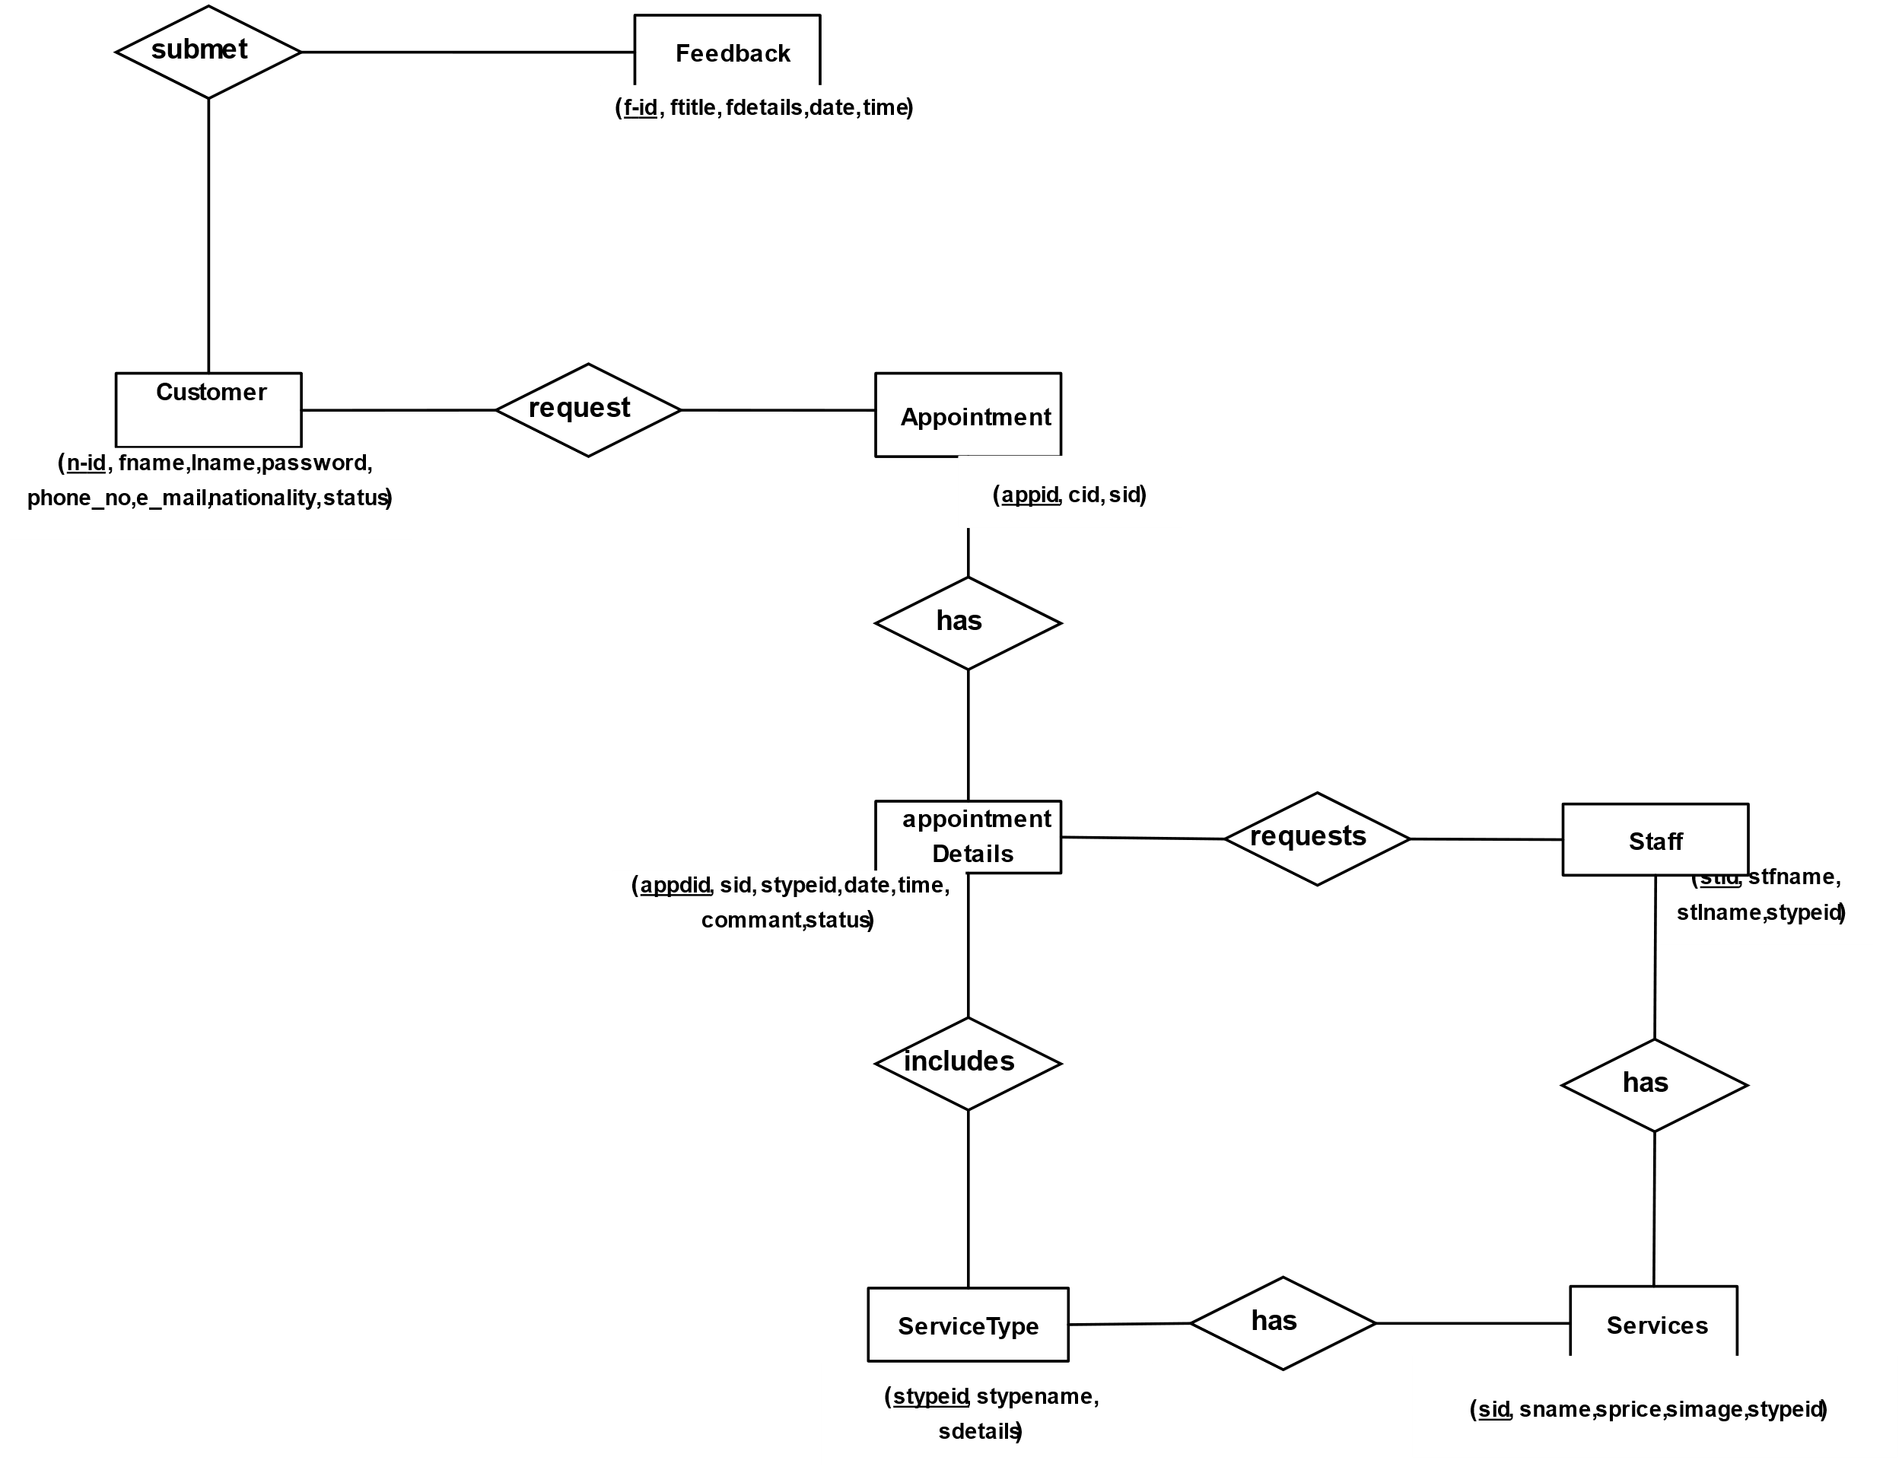

* **Programming Languages:** Python (for AI/Backend), JavaScript (for Frontend/Backend)
* **Frameworks:** Django/Flask or Node.js/Express (Backend), React/Angular/Vue.js (Frontend)
* **Database:** PostgreSQL / MySQL (Relational Database)
* **AI/ML Libraries:** TensorFlow / PyTorch, OpenCV, scikit-learn, NLTK/spaCy
* **AR Libraries/Tools:** WebXR API, AR.js, Three.js (or similar web-based AR solutions)
* **Platform:** Web Application (Cloud Hosted - e.g., AWS, Azure, GCP)

**Team Members:**

|  |  |  |  |  |  |
| --- | --- | --- | --- | --- | --- |
| S.  No. | Name of projectee | Enrollment No. | University Roll No. | Email | Contact No. |
| 1 | Ajendra Kumar | CB8487 | 301302222019 | 6603236[@rungta.org](mailto:krjitendra9931@gmail.com) | 6206957745 |
| 2 | Amit Kumar sah | CB8404 | 301302222156 | 6602977@rungta.org | 9155613775 |
| 3 | Dinbandhu Kumar | CB8347 | 301302222060 | 6601919[@rungta.org](mailto:krjitendra9931@gmail.com) | 8252681971 |
| 4 | Ayushman chandel | CB8503 | 301302222027 | 6603226[@rungta.org](mailto:krjitendra9931@gmail.com) | 7000774714 |

Signature of Project Guide Signature of Project Coordinator

Head of Department